Trailer: License Plate 13306. Registration copy is inside rear door
Control panel 115/230V 3phase 4 wire. Telemetry system is Sensaphone 2000 requiring a hard wire telephone line and will need to be programmed by new user with notification dialout numbers etc if to be used.
Sparge -original compressor replaced with a Busch Mink MM1144 BP rotary claw with Marathon Electric 7.5HP 3phase wired for 230V. Plumbed through a hydronic heat exchanger that is disconnected and loose in trailer for transport. Needs to be mounted under trailer once installed at site. Manifold has up to 8 legs available with some minor modifications to replace missing or broken flow meters and valves
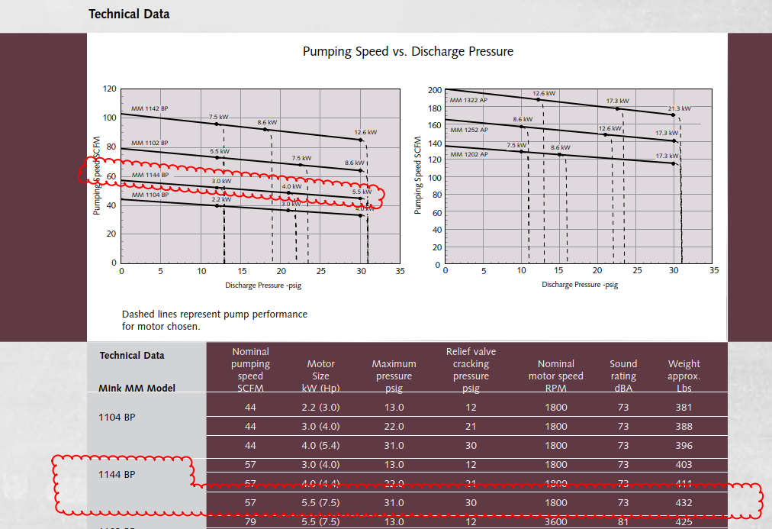
SVE – regenerative EN808 7.5HP 3phase wired for 230V. Fourteen leg manifold with exhaust redirect plumbing and valving to blower water out of lines. VLS has water transfer pump with carbon vessel.
