This guidance document is advisory in nature but is binding on an agency until amended by such agency. A guidance document does not include internal procedural documents that only affect the internal operations of the agency and does not impose additional requirements or penalties on regulated parties or include confidential information or rules and regulations made in accordance with the Administrative Procedure Act. If you believe that this guidance document imposes additional requirements or penalties on regulated parties, you may request a review of the document.
23-004 June 2023

Guidance for Clarifying Industrial Storm Water Inspections for Sector J Facilities
The purpose of this guidance document is to clarify the requirements of General Permit Number NER920000 (Industrial Storm Water) Section 4 – Inspections and Sector 8.J – Non-metallic Mineral Mining and Dressing. The clarification is important for facilities to understand their permit requirements when sector-specific requirements are applicable. See NDEE Industrial Storm Water Permit, Appendix B for definitions that pertain to this permit.
- Are the routine facility inspections required under Section 4.1.1 and inspections required under Section 8.J.4.2 considered to be separate inspections?
Routine inspections must be for all areas of the site, including production areas and parts of the site that are clearing or grading overburden. Section 8.J.4.2 inspections are for only areas where there is overburden clearing or soil is being moved. Conduct routine inspections quarterly during normal facility operating hours of all areas of the facility covered by the requirements in this permit, including, but not limited to:
- Areas where industrial materials or activities are exposed to storm water
- Areas identified in the SWPPP and those that are potential pollutant sources
- Areas where spills and leaks have occurred in the past 3 years
- All Outfalls
- All storm water control measures used to comply with the effluent limits contained in the permit
(This section pertains to all sectors and subsectors unless stated otherwise in your sector)
- What areas need to be inspected with each inspection type?
Sector J – Section 4 areas that need to be inspected include:
- Areas where industrial materials or activities are exposed to storm water
- Areas identifies in the SWPPP and those that are potential pollutant sources
- Areas where spills and leaks have occurred in the past 3 years
- All outfalls
- All storm water control measures used to comply with the effluent limits contained in this permit.
Section 4 states that once each quarter, you must collect a storm water sample and conduct a visual assessment of each sample from all outfalls. This applies to all sectors unless stated otherwise in your section of the permit. The visual sampling includes you to inspect:
- Color
- Odor
- Clarity
- Floating solids
- Settled solids
- Foam
- Oil sheen
- Other obvious indicators of storm water pollution
Section 4 areas may look like the example below, and will be subject to quarterly inspections and annual comprehensive inspections:
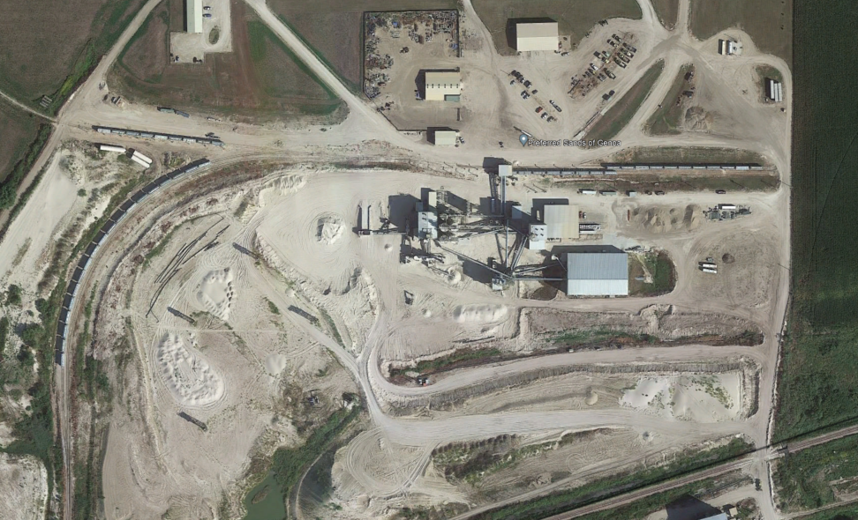

Another example of a project that is covered entirely by Section 4 of NER92000 and not 8.J.4.2:
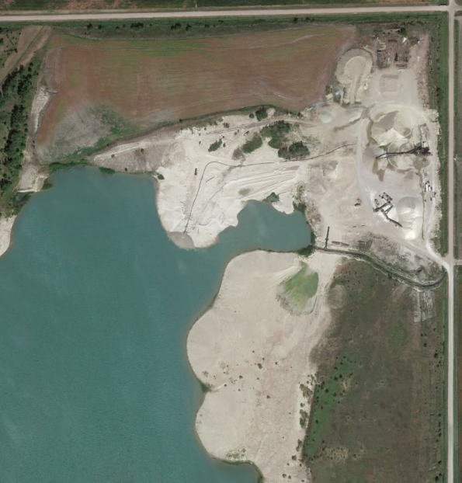

Section 8 applied to Sector J - earth disturbing activity. It requires the facility to monitor parts of their facility similarly to if that section was covered by a construction storm water permit. It applies to areas of the site that are affected by:
- clearing
- grading, and/or
- excavation activities and areas used for storage of loose soil and earth materials that are exposed to precipitation.

Section 8 inspection areas are areas removing overburden and soil. They are not the areas of the site that are production areas. Please see the blue areas in the diagram below to see which areas that must be inspected according to the schedule in 8.J.4.2.

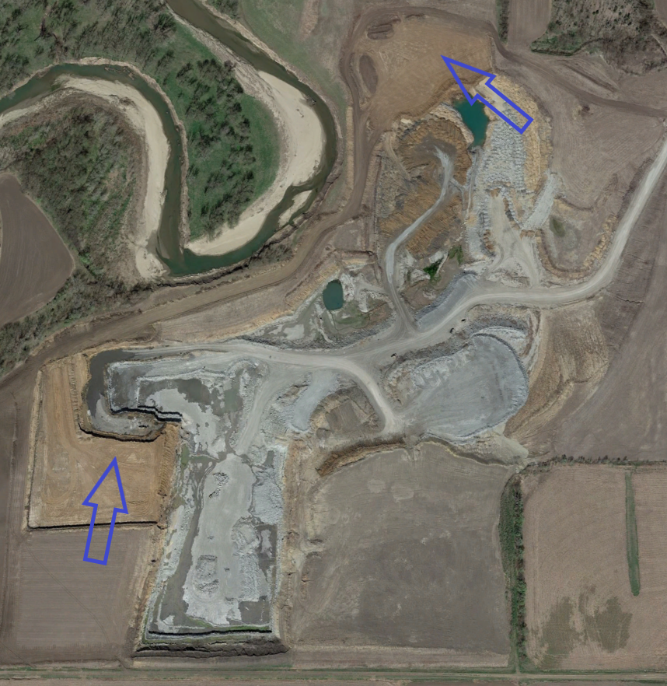

As you can see, these areas of the project are moving soil. Other areas are not subject to 8.J.4.2.
Sedimentation and erosion control measures implemented must be observed to ensure proper operation. Discharge locations must be inspected to ascertain whether erosion control measures are effective in preventing significant impacts to waters of the state, where accessible. Where discharge locations are inaccessible, nearby downstream locations must be inspected to the extent that such inspections are practicable. Locations where vehicles enter or exit the site must be inspected for evidence of significant off-site sediment tracking.

- How frequently does each inspection type need to be completed?
Section 4 – Visual assessments need to be conducted quarterly for all sectors unless stated otherwise in your section. These sections of the site are also subject to annual comprehensive inspections.
Section 8.J.2 – Inspections must be conducted at least once every 14 calendar days and within 24 hours of the end of a storm event of 0.5 inches or greater. Inspection frequency may be reduced to at least once every month if the entire site is temporarily stabilized (pursuant to Part 8.J.4.3.2).
See Part 8.J.8.1 for inspection requirements for inactive and unstaffed sites.
- Which areas fall under Section 4.1.1 inspection requirements?
- Areas where industrial materials or activities are exposed to storm water
- Areas identified in the SWPPP and those that are potential pollutant sources (see Part 5.1.3)
- Areas where spills and leaks have occurred in the past 3 years
- All outfalls and
- All storm water control measures used to comply with the effluent limits contained in this permit.
- Which areas fall under Section 8.J.4.2 inspection requirements?
Location of Inspections. Inspections must include all areas of the site disturbed by clearing, grading, and/or excavation activities and areas used for storage of materials that are exposed to precipitation. Sedimentation and erosion control measures implemented must be observed to ensure proper operation. Discharge locations must be inspected to ascertain whether erosion control measures are effective in preventing significant impacts to waters of the state, where accessible. Where discharge locations are inaccessible, nearby downstream locations must be inspected to the extent that such inspections are practicable. Locations where vehicles enter or exit the site must be inspected for evidence of significant off-site sediment tracking.
- Section 8.G.4.2.1 states that inspections for sections affected by earth disturbing activities can be reduced to monthly if the entire site is temporarily stabilized. Is this requirement specific to the mining site where earth-disturbing activities are taking place, or both the mining site and the plant site?
According to your facility, you fall under Sector J: Mineral Mining and Dressing
Which would apply to just the mining site.
- Are perimeter berms placed around cleared mining areas adequate to meet the temporary stabilization requirements described in 8.J.4.3.2?
Yes, if it minimizes mobilization of sediment or other pollutants until such time as the active mining phase commences.
- Section 8.J.4.2.3 states that the information listed in Part 4.1 must be included on the Section 8.J.4.2 inspection reports for sites affected by earth disturbing activities. Which information in Section 4.1 is this requirement specifically referring to?
- The inspection date and time
- The name(s), title(s), and signature(s) of the inspector(s)
- Weather information and a description of any discharges occurring at the time of the inspection
- Any previously unidentified discharges from and/or pollutants at the facility
- Any evidence of, or the potential for, pollutants entering the drainage system
- Any control measures needing maintenance or repairs
- Any failed control measures that need replacement
- Any incidents of noncompliance observed; and
- Any additional control measures needed to comply with the permit requirements.
- What is considered to meet final stabilization requirements regarding open water and non-vegetated slurry sand areas around portions of the site?
A site or portion of a site is “finally stabilized” when it has implemented all applicable Federal, State, and local reclamation requirements and the site has been returned to a beneficial use.

Produced by: Nebraska Department of Environment and Energy, P.O. Box 98922, Lincoln, NE 68509-8922; phone (402) 471-2186. To view this, and other information related to our agency, visit our web site at http://dee.ne.gov.

