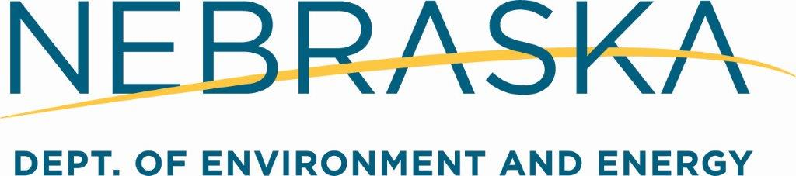

Suite 400, 1200 "N" Street, The Atrium
P.O. Box 98922 Lincoln, NE 68509-8922
(402) 471-4210

SOLID WASTE PROCESSING FACILITY CONSTRUCTION CERTIFICATION

Name of Facility:

Mailing Address:
City/State/Zip: Telephone:
Legal Description of Facility: (NE, SE, NW, SW) Quarter, (NE, SE, NW, SW) Quarter,
Section , Township (N) (S), Range (E) (W),
County:

Materials Recovery Facility Transfer Station Compost Site Other Processing Facility

I hereby certify that the above referenced solid waste processing facility has been
constructed pursuant to the facility’s permit application approved by the Nebraska Department of Environment and Energy and the rules and regulations of Title 132 – Integrated Solid Waste Management Regulations.

Date of Construction Completion

Signature of Owner or Date
PE Registered in the State of Nebraska

Printed Name of Owner or
PE Registered in the State of Nebraska (Professional Engineer Seal)

Revised 1-2020 WAS054-2020

